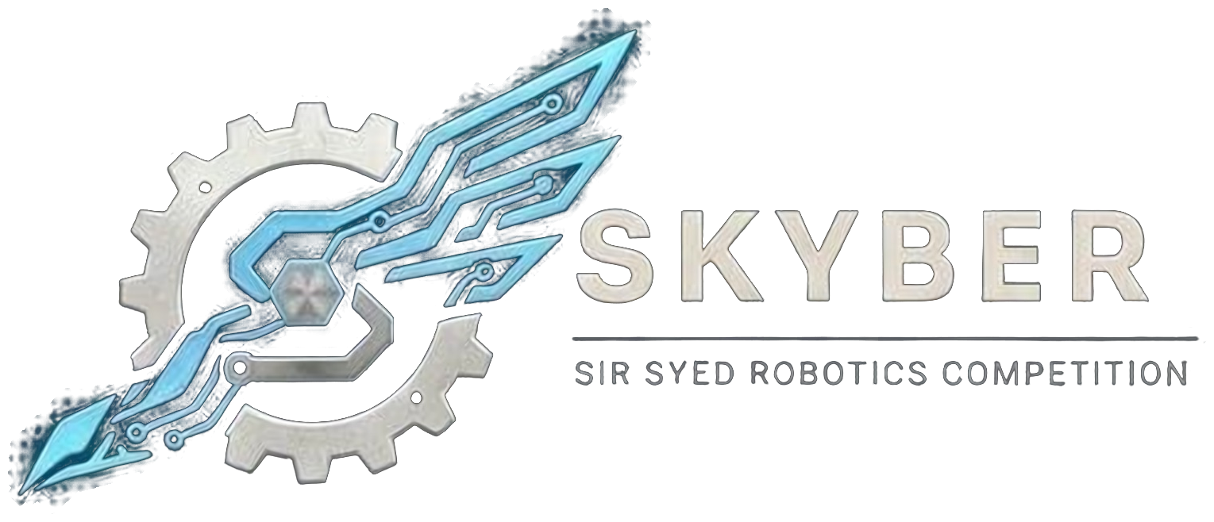 | SIR SYED ROBOTICS COMPETITION  SKYBER 2026 | SSUET | OFFICIAL RULEBOOK | 

WATER ROCKET GLIDER MODULE: OFFICIAL RULEBOOK
Teams build a glider around a single 1 litre bottle. The glider is launched at 45 degrees by water pressure from the SKYBER launch pad and must fly straight and far. The longest valid flight wins. This module follows the specifications of the PSC Water Rocket Glider Challenge, so gliders built for that event can be reused, and adds the safety rules below.
1. Teams:
- Eligibility: Open to university and college students aged 18 or over. No one under 18 may attend. Proof of enrollment (confirmation text or email, or registration number) is required.
- Team size: Up to 3 members. One glider per team.
- Entry fee: Rs 2,000 per team.
- Roster: Team members cannot be added or changed after registration closes on 16 November 2026. Students from different institutions may join one team.
- Multiple events: A person may belong to at most two teams, in different events, and only if the schedules do not clash.
- ID card: Every participant shows a printed ID card at entry. The template is sent with the registration confirmation.
- Building: Gliders are built at home and brought to the venue. Nothing is built at the venue.
2. Glider Specifications:
Parameter | Specification
Bottle | One unmodified 1 litre PET bottle of the type announced with this rulebook, used as the fuselage with the cap end facing backward. Cutting, reinforcing or otherwise modifying the bottle is not allowed.
Wingspan | 45 cm maximum, wingtip to wingtip, including the bottle.
Length | 50 cm maximum, nose to tail.
Empty weight | 200 g maximum, including the bottle.
Materials | Foam board, card, balsa, plastic, paper, tape, glue and 3D-printed parts. No metal anywhere on the glider (screws, wire, pins, foil). No glass or sharp parts.
Propulsion | Water pressure only. No motors, batteries or springs.
Nozzle | The neck and nozzle must stay clear and fit the SKYBER launch tube. Nothing may block the tube. No tape may cross the nozzle opening.

All measurements are limits, not targets. A smaller glider is allowed.
3. Launch Ground and Launch Pad:
- Ground: An open launch ground with at least 60 m of clear length and no road, window or parked vehicle in the flight path.
- Corridor: A straight corridor 8 m wide, marked on the ground. The glider must stay inside it.
- Launch pad: The SKYBER launch pad holds the bottle at 45 degrees. It is fitted with a pressure gauge and a relief valve, and its pressure is limited to 30 psi. Marshals fill the same amount of water for every team.
- Operators: Only trained marshals pump and release the launch pad, from behind a safety line, using a release cord.
4. Inspection and Launch Procedure:
- Inspection: Every glider is checked for weight, span, length, metal and an unmodified bottle with no cracks or deep scratches. A glider that fails may be fixed once and brought back. Passed gliders get a numbered sticker, and only numbered gliders may launch.
- Launch order: By random draw. A team not ready within 2 minutes of being called forfeits the attempt.
- Attempts: Two attempts per team. The best valid flight counts. No repairs between attempts, except removing tape or small loose parts.
- Wind: Marshals may hold launches in strong wind.
5. Scoring:
- Valid flight: The glider flies a straight path and lands inside the corridor.
- Invalid flight: The glider leaves the corridor, hits a boundary or crashes straight after launch. That attempt scores zero.
- Distance: Measured from the launch line to where the glider first touches the ground. The longest valid flight wins.
- Ties: The better second attempt wins. If still tied, the lighter glider wins.
- Awards: First, second and third place. The winner receives a cash prize and a plaque; certificates for all participants, with a separate certificate for 2nd and 3rd place.
6. Rules, Violations and Disqualification:
- Disqualification: A glider that fails inspection a second time; changing the glider after inspection; tampering with the launch pad; ignoring a marshal’s instruction; unsafe conduct at the launch ground; any act against fair play.
- Conduct: All members are expected to be responsible, follow these rules and respect organizers, judges, volunteers and other teams. Fighting, abusive language, harassment or unruly behavior means immediate disqualification and removal from the premises.
7. Safety:
- Everyone stays behind the launch line. Nobody goes downrange until the marshal calls “clear”.
- Never point a pressurized bottle at anyone.
- Eye protection is required at the launch ground. Participants should bring their own.
- Any marshal can stop a launch at any time, and their instructions must be followed immediately.
- The launch pad and ground must be signed off by the faculty safety officer before the event. If the sign-off is not given, the glider event does not run and entry fees are refunded.
8. Queries:
- Clarifications and changes: Officials may clarify rules. Any substantive change is announced to all team leaders before it is applied, and no team receives a private exception. Rules are frozen on 1st November 2026; after that only dated safety corrections are issued.
Competition Details:
Date: 18 November 2026
Venue: Sir Syed University of Engineering & Technology (SSUET), Karachi. Room to be announced.
Event: SKYBER 2026
Contact Information:
Contact no.: 03322396805
Event Updates:
Participants are advised to follow the official SKYBER 2026 announcements for updates regarding the competition schedule, venue, reporting times and other instructions.

