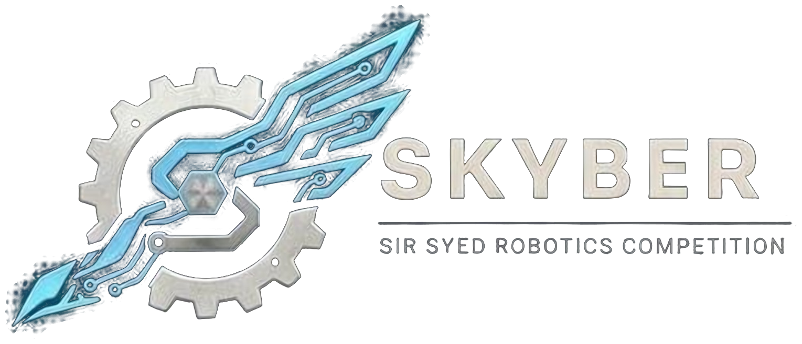 | SIR SYED ROBOTICS COMPETITION  SKYBER 2026 | SSUET | OFFICIAL RULEBOOK | 

ROBO SUMO MODULE: OFFICIAL RULEBOOK
Robo Sumo is a head-to-head contest between two remote-controlled robots on a raised circular ring. Each robot tries to push the other off the ring, or make it fall off on its own. The first robot to fall off loses the round.
1. Teams:
- Eligibility: Open to university and college students aged 18 or over. No one under 18 may attend. Proof of enrollment (confirmation text or email, or registration number) is required.
- Team size: Up to 3 members. One robot per team. One team member operates the controller.
- Entry fee: Rs 2,000 per team.
- Roster: Team members cannot be added or changed after registration closes on 16 November 2026. Students from different institutions may join one team.
- Multiple events: A person may belong to at most two teams, in different events, and only if the schedules do not clash.
- ID card: Every participant shows a printed ID card at entry. The template is sent with the registration confirmation.
2. Robot Specifications:
Parameter | Specification
Dimensions | 20 × 20 × 20 cm cube at all times, including during a match. No part may extend beyond the cube and there are no deployable parts.
Weight | 5.0 kg maximum, excluding purely decorative items.
Voltage | 12.6 V DC maximum when fully charged. Onboard battery only.
Motors | Brushed DC gear motors and servo motors only, with a maximum of 4 motors. Brushless motors and electronic speed controllers (ESCs) are prohibited.
Wheels and traction | Rubber, silicone or polyurethane tires. No glue, tape or sticky residue. Magnets are not allowed.
Shape | Wedges and scoops are allowed with smooth leading edges. Lifters, flippers, spikes and weapons are prohibited.
Control | Remote-controlled by wireless link only (Bluetooth or 2.4 GHz). No Wi-Fi control and no tethers. The robot must stop if the signal is lost.
Electronics | An easy-to-reach ON/OFF switch is mandatory. Wiring and electronics must be enclosed. Exposed open electronics are prohibited.

Prohibited conduct
At all times a robot must not: emit smoke or fire; leak, stain or soil; disperse powder, grit or grime; spray, throw or use projectiles; jam, shock or electromagnetically interfere; snare or entangle with nets or rope; scratch, gouge or scrape the ring. Normal scuffs from pushing and scoops are expected and acceptable.
3. Ring:
- Ring: A circular, raised platform of rigid, non-magnetic material with a smooth matte black surface. Diameter 154 cm. Height at least 5 cm above the floor. No walls or barriers.
- Out of the ring: A robot is out the moment any part of it goes over the edge and falls off the platform.
- Run-off and spectators: A 1 m soft run-off mat surrounds the ring and spectators stay at least 2 m back.
4. Inspection and Match Flow:
- Start: The referee calls “ready” and then gives the start signal. Any movement before the signal is a false start: a warning, and a second warning in the same round loses the round.
- Activity: A robot must visibly move at least every 5 seconds. If the robots do not touch for 20 seconds, the round restarts with a warning to the more passive robot. A robot immobilised for 10 seconds loses the round.
- Round result: The first robot to fall off loses, even if the other falls off afterwards. If both fall at the same time the round is nullified and replayed. Referees may restart a round if the robots are entangled or deadlocked.
- No-show and repairs: A team not ready within 2 minutes of being called forfeits. Teams get 10 minutes for repairs between rounds.
5. Tournament Format and Scoring:
- Bracket: A public random draw into a single-elimination bracket, with a play-in match if the number of teams is uneven and a third-place match. The draw is made after registration closes.
- Rounds: Early rounds are a single 3-minute round. Quarter-finals onward are best of 3 rounds of 3 minutes.
- Overtime: If a round has no winner after 3 minutes, 1 minute of overtime is played. If it is still undecided, three referees vote, in this order of criteria: ring control, pushing, then attacks. The majority wins.
6. Rules, Violations and Disqualification:
- Disqualification: Deliberate damage to the ring or an opponent’s robot; any prohibited mechanism or conduct listed above; failing inspection or changing the robot without approval; blocking another team’s wireless signal; unsafe operation; any act against fair play.
- Referee discretion: A round may be ended and a winner chosen if smoke, fire, damage or any other violation occurs, or if no progress is likely.
- Conduct: All members are expected to be responsible, follow these rules and respect organizers, judges, volunteers and other teams. Fighting, abusive language, harassment or unruly behavior means immediate disqualification and removal from the premises.
7. Safety:
- Batteries: LiPo packs stay in fire-resistant bags (supplied by the team) whenever they are outside the robot. There is no charging at the venue, so teams arrive with charged packs and spares. Swollen, damaged or unlabelled packs are rejected at inspection. Batteries and wiring must be secured and insulated against short circuits, with no exposed wires.
- Hazards: No sharp edges or dangerous moving parts. No flames, explosives, chemicals, liquids or pressurized systems. Lasers and bright lights must be eye-safe (Class 2 or below).
- Authority: Referees and inspectors may halt, disable or disqualify any robot judged a fire or physical hazard. Marshals may require eye protection near arenas.
- Responsibility: Teams are fully responsible for the structural integrity and electrical safety of their robot. The organizers and the university are not liable for damage to robots.
8. Queries:
- Clarifications and changes: Officials may clarify rules. Any substantive change is announced to all team leaders before it is applied, and no team receives a private exception. Rules are frozen on 1st November 2026; after that only dated safety corrections are issued.
Competition Details:
Date: 18 November 2026
Venue: Sir Syed University of Engineering & Technology (SSUET), Karachi. Room to be announced.
Event: SKYBER 2026
Contact Information:
Contact no.: 03322396805
Participants are advised to follow the official SKYBER 2026 announcements for updates regarding the competition schedule, venue, reporting times and other instructions.

