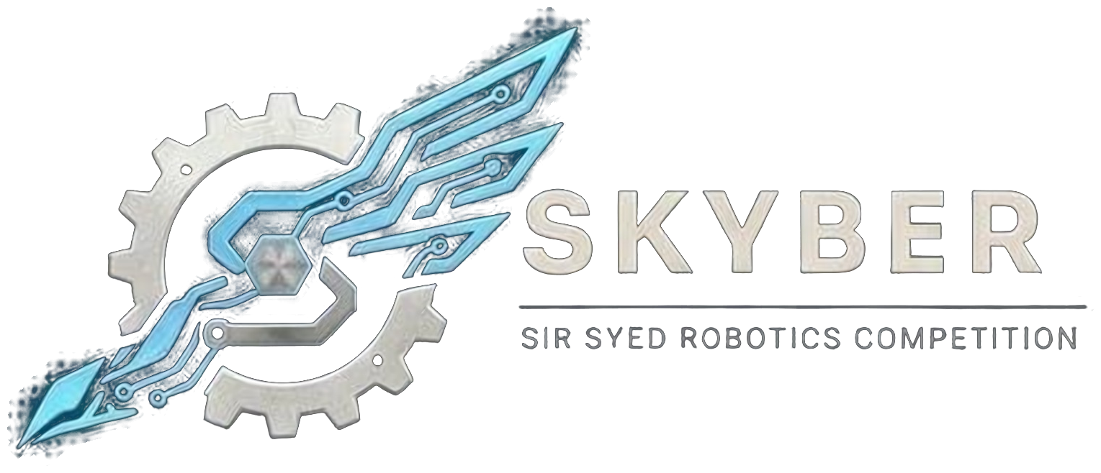 | SIR SYED ROBOTICS COMPETITION  SKYBER 2026 | SSUET | OFFICIAL RULEBOOK | 

ROBO WAR (LIGHTWEIGHT COMBAT, 5.44 KG) MODULE: OFFICIAL RULEBOOK
Robo War is a combat sport in which two remote-controlled robots fight inside an enclosed arena. Teams design and build a robot with strong offence, good armour and fast movement. Matches are decided on points, by knockout, or by the judges’ decision. This is the lightweight class, with a weight limit of 5.44 kg (12 lb).
1. Teams and Eligibility:
- Eligibility: Open to university and college students aged 18 or over. No one under 18 may attend. Proof of enrollment (confirmation text or email, or registration number) is required.
- Team size: Up to 3 members. One team captain. One robot per team, and a team may not share a robot with another team.
- Entry fee: Rs 3,000 per team.
- Captain: Only the team captain may speak to referees, submit the safety report, or file a protest.
- Roster: Team members cannot be added or changed after registration closes on 16 November 2026. Students from different institutions may join one team.
- Multiple events: A person may belong to at most two teams, in different events, and only if the schedules do not clash.
- ID card: Every participant shows a printed ID card at entry. The template is sent with the registration confirmation.
2. Robot Specifications:
Parameter | Specification
Weight | 5.44 kg (12 lb) maximum, including all batteries, weapons, fluids and attachments. There is no tolerance: a robot over the limit does not play. A robot may be re-weighed after any repair.
Size | Fits inside 15 × 15 × 12 inches at the start, measured with all parts. A robot may unfold after the start signal, but no part may leave the arena.
Voltage | 25.2 V DC maximum when fully charged (6S LiPo or equivalent).
Batteries | LiPo, Li-ion, LiFe and NiMH allowed. Swollen, punctured or damaged batteries are prohibited. Battery terminals must be protected from a direct short. The battery is secured inside the armour. A fuse or protection circuit is required in the power circuit.
Control | Hobby 2.4 GHz radio only, with a transmitter and receiver. Bluetooth, Wi-Fi and any other link are prohibited. Radio channels are assigned by the organizers at check-in.
Failsafe | If the radio signal is lost, or the transmitter is switched off, the drive and every weapon must stop within 1 second. This is tested at inspection by switching off the transmitter.
Power switch and LED | An easy-to-reach main power switch on the outside of the robot, and a bright power LED visible from outside the arena.
Kill switch | An easy-to-reach main kill switch on every robot, separate from the power switch, that stops the drive and all weapons.
Electronics | Any microcontroller or ready-made controller board. Onboard power only: no external power supply and no wired connection to the surroundings. Wiring must be enclosed and protected.
Multi-part robots | A robot made of several parts counts as one robot. The combined weight of all parts must stay within the limit. A multi-part robot loses only when all its parts have stopped moving.

3. Weapons:
- Allowed: Spinners, flippers, lifters, wedges, plows, hammers, axes, saws and blades. Electric and spring-powered weapons are allowed. Commercial blades are limited to 4 inches. Tethered projectiles are not allowed.
- Prohibited: Flames, explosives, liquids, pneumatic and pressure systems, nets, ropes and entanglers, radio jammers, lasers, strobes, and any device that blinds, obscures or disperses material.
- Arming: The weapon is off at power-on. It is armed only inside the arena, on the referee’s command. Outside the arena a weapon lock must be fitted.
- Stopping: Every weapon must come to rest within 30 seconds of a power cut or loss of signal. Each weapon stops automatically on signal loss or kill-switch activation.
- Guards: Sharp edges, spikes and spinning blades require guards outside the arena. Guards are not included in the weight limit.
- Weapon falling off: A weapon that comes off by itself, because of poor construction, loses the match and the robot must be re-inspected. A weapon torn off by an opponent counts as damage to the opponent.
- Weapon testing: Weapons may be tested only in the test box provided at the venue, and only under a marshal’s supervision.
4. Safety Report, Inspection and Weigh-in:
- Safety report: Submitted with registration, by 15 November 2026. It covers weapon type and mass, motors, battery, failsafe design, and photographs of the robot. The faculty safety officer may refuse any robot based on the report.
- Weigh-in and measurement: All robots are weighed and measured at check-in. The limits are strictly enforced.
- Inspection: A physical inspection (size, weight, guards, battery, fuse, power switch, LED and kill switch) and a functional inspection (failsafe test by switching off the transmitter, and a demonstration of weapons stopping on command) are carried out before a team may compete.
- After any change: Any repair, part replacement or modification must be reported to the technical inspectors, who may re-check weight, size and safety before the next match.
- Failed inspection: A robot that fails once may be corrected and re-inspected before its match. A robot that cannot pass cannot compete.
5. Arena:
- Enclosure: A fully enclosed arena with a floor of about 1.5 m square, walls of 8 mm polycarbonate and a roof. The arena has no hazards inside it. These are starting values; the reviewer’s sign-off overrides them.
- Entry and exit: Only marshals may open the arena or arm and disarm robots. Nobody enters the arena while a robot is armed.
6. Match Rules:
- Duration: Each match lasts 3 minutes from the referee’s start signal.
- Start: Both pilots hold their transmitters. The referee gives the countdown. Any movement or weapon activity before the start signal is a false start: a warning on the first offence, and a 5-point penalty from the second.
- Immobile robot: A robot that cannot produce controlled movement for 10 seconds is counted by the referee. If it does not recover within a 10-second count, the referee declares the opponent the winner.
- Stop: After any stop, both pilots hold their transmitters up with their hands visible. Weapons stay off until a marshal declares the arena safe. Play restarts only after the referee’s 10-second countdown and official signal.
- Timeouts: No timeouts are called during a match, except under the immobile-robot rule above. Teams may not make adjustments inside the arena.
- Ejection: A robot pushed or tossed out of the arena loses the match.
- Early end: A match ends early only for a safety hazard or the incapacitation of a robot. The referee then decides the result under the scoring rules below.
- Interference: Radio jamming, hacking, or touching another team’s controller is disqualification.
7. Scoring:
If no robot is knocked out, the result is decided by three judges, who score each match against published criteria. The judges watch the match and do not confer during it.
Category | Max points | What is scored
Damage | 5 | Visible, functional destruction to armour, drive, or weapon systems. Cosmetic scratches do not count.
Aggression | 3 | The frequency and intensity of attacks initiated by the robot.
Control | 3 | The ability to choose the battle location, avoid hazards and push the opponent.

- Category winner: For each category, the robot with the higher score from the judges takes that category’s points.
- Majority: The robot that wins the majority of the judges’ cards wins the match.
- Ties: A tied card goes to damage. If the judges’ cards still tie, the match goes to a 1-minute overtime round under the same rules. If it is still tied, the judges’ final decision is binding.
- Consistency: Judges apply the same published criteria to every team and record their reasons on the scoring sheet.
8. Penalties and Disqualification:
Violation | Consequence
Weight over 5.44 kg | Disqualification (no tolerance)
Size over the limit at the start | Robot must be corrected before the match; if not corrected, disqualification
False start | Warning, then 5-point penalty from the second
Unreported repair or modification | Penalty, or disqualification for a repeat
A weapon falling off by itself | Loses the match; re-inspection before any further match
A weapon used outside its approved limit, or flames | Disqualification
Damaged or swollen battery, or a battery without a fuse | Disqualification
Failing the safety check, or ignoring safety staff | Disqualification
Radio jamming, hacking, or interfering with another team’s controller | Disqualification
Arena interference by team members during a match | Penalty or disqualification
Requesting an inspection in the middle of a match | Penalty to the team, awarded to the opponent
Unsportsmanlike conduct | Disqualification

- Conduct: All members are expected to be responsible, follow these rules and respect organizers, judges, volunteers and other teams. Fighting, abusive language, harassment or unruly behavior means immediate disqualification and removal from the premises.
- Safety rulings: Referees hold sole authority to pause, stop or assess whether a robot may continue. Nobody enters the arena or touches a robot without the referee’s permission.
9. Safety:
- Teams are fully responsible for the structural integrity and electrical safety of their robot. The organizers and the university are not liable for damage to robots.
- LiPo and Li-ion batteries stay outside the arena while not in use, in fire-resistant bags supplied by the team. There is no charging at the venue, so teams arrive with charged batteries.
- No robot may leave the arena area with an armed weapon. Weapons are unarmed on the referee’s signal before anyone leaves the arena.
- Marshals carry an extinguisher and sand at the arena. Any marshal may stop a match and any robot that presents a fire or physical hazard.
- Teams follow all official instructions. Ignoring official directives may lead to penalties or disqualification.
10. Queries:
- Clarifications and changes: Officials may clarify rules. Any substantive change is announced to all team leaders before it is applied, and no team receives a private exception. Rules are frozen on 1st November 2026; after that only dated safety corrections are issued.
Competition Details:
Date: 18 November 2026
Venue: Sir Syed University of Engineering & Technology (SSUET), Karachi.
Event: SKYBER 2026
Contact Information:
Contact no.: 03322396805
Participants are advised to follow the official SKYBER 2026 announcements for updates regarding the competition schedule, venue, reporting times and other instructions.

