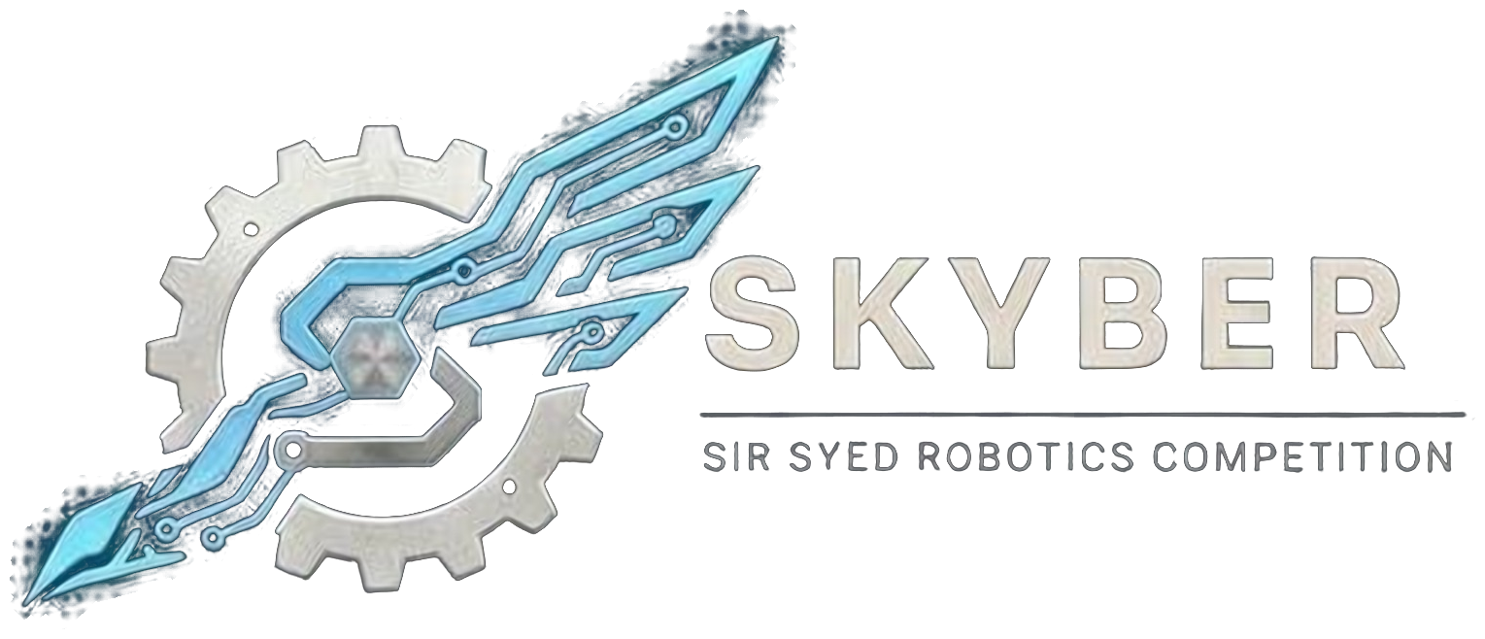 | SIR SYED ROBOTICS COMPETITION  SKYBER 2026 | SSUET | OFFICIAL RULEBOOK | 

ROBO SOCCER MODULE: OFFICIAL RULEBOOK
The Robo Soccer event challenges remote-controlled robots to outmaneuver opponents and score by pushing or kicking the ball into the opponent’s goal within the match time. Matches are one robot against one robot.
1. Teams:
- Eligibility: Open to university and college students aged 18 or over. No one under 18 may attend. Proof of enrollment (confirmation text or email, or registration number) is required.
- Team size: Up to 3 members. One robot per team, and one pilot at a time.
- Entry fee: Rs 2,000 per team.
- Roster: Team members cannot be added or changed after registration closes on 16 November 2026. Students from different institutions may join one team.
- Multiple events: A person may belong to at most two teams, in different events, and only if the schedules do not clash.
- ID card: Every participant shows a printed ID card at entry. The template is sent with the registration confirmation.
2. Robot Specifications:
Parameter | Specification
Dimensions (L × W × H) | 30.5 × 30.5 × 30.5 cm (12 inches) maximum, including all mounted attachments.
Weight | 1.5 kg maximum, including the battery.
Voltage | 12.6 V DC maximum (3S). Boost converters are prohibited.
Control | Manual wireless remote control only (Bluetooth or 2.4 GHz). No Wi-Fi and no tethered cable. Autonomous control is prohibited. The robot must stop if the signal is lost.
Build | Custom chassis only. Lego, EV3 kits, toy cars and ready-made RC cars are prohibited.
Motors | Brushed DC gear motors and servo motors only, with a maximum of 6 motors including any kicker or dribbler. Drive motors are 300 RPM or less at the output shaft. Brushless motors and ESCs are prohibited.
Handling mechanisms | Pushing blades, passive plows, dribblers and mechanical or servo kickers are allowed. A dribbler may cover at most 20% of the ball’s diameter. A kicker runs from the main battery and must not lift the ball above wall height. Capacitor, solenoid and pneumatic kickers, claws, grippers, suction, sticky pads and ball-locking enclosures are prohibited.
Offensive hardware | Flippers, lifters, spikes, entanglers, liquids, flames and signal jammers are prohibited.
Power and switch | Onboard battery only. Fully insulated wiring and an accessible physical ON/OFF switch are mandatory.

3. Field and Ball:
- Field: A flat, enclosed indoor field of about 2.4 × 1.8 m, bordered by low walls of 10–15 cm. Two goals, about 50 cm wide, at opposite ends. Clearly marked start zones.
- Ball: An orange ball of about 40 mm, supplied by the organizers.
- Operators: Operators stay in the marked operator area outside the walls throughout the match.
4. Inspection and Match Flow:
- Inspection: Officials verify dimensions, weight, voltage, mechanisms and communication reliability. The failsafe is tested by switching off the transmitter. Changing hardware after inspection without approval means disqualification.
- Start: Robots start stationary in their start zones. The referee starts play with a whistle count. Moving before the whistle is a false start: a warning, then a yellow card.
- Ball play: Robots may push, kick or dribble the ball. Trapping the ball so that an opponent cannot contest it for more than 3 seconds is a foul.
- Stoppages: If robots are entangled or jammed for more than 10 seconds, the referee stops play and restarts with a neutral kickoff and no penalty.
- Timeout: Each team has one 60-second technical timeout per match, with the match clock stopped. Operators may touch their robot only during a timeout or when the referee permits.
- No-show and repairs: A team not ready within 2 minutes of being called forfeits. Teams get 10 minutes for repairs between rounds.
5. Tournament Format and Scoring:
- Match length: Early rounds are one 4-minute period. Semi-finals and the final are two 3-minute halves with a 1-minute break and a change of ends.
- Scoring: A goal (1 point) is scored when the whole ball crosses the opponent’s goal line. An own goal counts for the opponent. A ball that leaves the field is returned to the centre.
- Ties: A tied match goes to a 1-minute golden goal. If still tied, a shootout: each robot gets three attempts of 15 seconds to push the ball from the centre line into the goal, then sudden death if needed.
6. Rules, Violations and Disqualification:
Offense | Consequence
Parking in your own goal area for more than 5 seconds, or pinning an opponent for more than 5 seconds | Warning, then a yellow card
Deliberate ramming off the ball or deliberate damage | Yellow card; deliberate damage to a robot, the ball or the field is disqualification
Two yellow cards in one match | Red card: the robot is ejected for the rest of the match
Using an illegal holding or trapping mechanism | Immediate −1 penalty and 60 seconds to remove it; a second violation in the same match is a forfeit
Three penalty points in one match | Forfeit
Exceeding a size, weight or voltage limit | Disqualification
Jamming or trying to take over an opponent’s control link | Disqualification
Physical interference by team members during live play | Match forfeit

- Wireless rules: The control type and frequency are declared at registration. Bluetooth and standard 2.4 GHz radios are allowed. Bluetooth devices must have a unique name and PIN and are paired at the match desk. Transmitters are held at the impound desk until the team’s match. Deploying jammers or trying to take over another team’s control link is disqualification.
- Conduct: All members are expected to be responsible, follow these rules and respect organizers, judges, volunteers and other teams. Fighting, abusive language, harassment or unruly behavior means immediate disqualification and removal from the premises.
7. Safety:
- Batteries: LiPo packs stay in fire-resistant bags (supplied by the team) whenever they are outside the robot. There is no charging at the venue, so teams arrive with charged packs and spares. Swollen, damaged or unlabelled packs are rejected at inspection. Batteries and wiring must be secured and insulated against short circuits, with no exposed wires.
- Hazards: No sharp edges or dangerous moving parts. No flames, explosives, chemicals, liquids or pressurized systems. Lasers and bright lights must be eye-safe (Class 2 or below).
- Authority: Referees and inspectors may halt, disable or disqualify any robot judged a fire or physical hazard. Marshals may require eye protection near arenas.
- Responsibility: Teams are fully responsible for the structural integrity and electrical safety of their robot. The organizers and the university are not liable for damage to robots.
8. Queries:
- Clarifications and changes: Officials may clarify rules. Any substantive change is announced to all team leaders before it is applied, and no team receives a private exception. Rules are frozen on 1st
- November 2026; after that only dated safety corrections are issued.
Competition Details:
Date: 18 November 2026
Venue: Sir Syed University of Engineering & Technology (SSUET), Karachi.
Event: SKYBER 2026
Contact Information:
Contact no.: 03322396805
Participants are advised to follow the official SKYBER 2026 announcements for updates regarding the competition schedule, venue, reporting times and other instructions.

