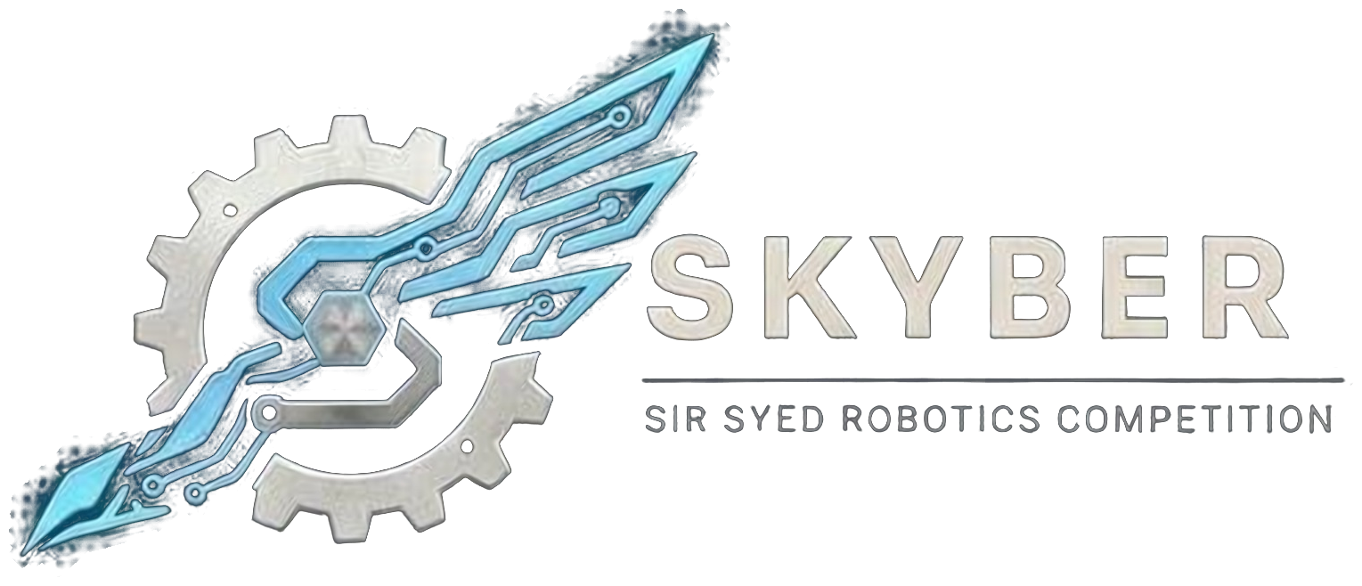 | SIR SYED ROBOTICS COMPETITION  SKYBER 2026 | SSUET | OFFICIAL RULEBOOK | 

ROBO RACE MODULE: OFFICIAL RULEBOOK
The Robo Race challenges teams to drive a remote-controlled robot across an obstacle course with inclines, bumps and narrow sections, from start to finish in the shortest total time. The event is a three-stage ladder.
1. Teams:
- Eligibility: Open to university and college students aged 18 or over. No one under 18 may attend. Proof of enrollment (confirmation text or email, or registration number) is required.
- Team size: Up to 3 members. One robot per team. Only one team member may hold the controller during a run.
- Entry fee: Rs 2,000 per team.
- Roster: Team members cannot be added or changed after registration closes on 16 November 2026. Students from different institutions may join one team.
- Multiple events: A person may belong to at most two teams, in different events, and only if the schedules do not clash.
- ID card: Every participant shows a printed ID card at entry. The template is sent with the registration confirmation.
2. Robot Specifications:
Parameter | Specification
Size | 10 × 10 × 10 inches maximum at the start. Parts may extend after the start only if the robot fit the limit at the start.
Weight | 1.5 kg maximum, including the battery and all attached parts.
Voltage | 12.6 V DC maximum when fully charged (3S LiPo or Li-ion accepted). Power banks are allowed.
Motors | Brushed DC geared motors and servo motors only, with a maximum of 6 motors in total. Maximum 300 RPM at the output shaft, with no load. Stall current 5 A or less per motor. Brushless or drone motors, motors without a gearbox, fans, propellers and anything that flies are prohibited.
Wheels and drive | Maximum wheel diameter 100 mm. Tracks, legs and other drive systems are allowed.
Control | Remote-controlled by wireless link only: Bluetooth, 2.4 GHz RC/RF, or Wi-Fi on an organizer-assigned channel. Wired control needs organizer approval. The motors must stop if the signal is lost. Sensors (ultrasonic, IR, gyro/IMU, cameras) may be used as aids, but a person must drive the robot.
Electronics and power | Any microcontroller. An easy-to-reach ON/OFF switch is mandatory. Batteries must have a fuse or protection circuit.
Not allowed | Kit-based robots, model kit robots and ready-made RC cars.

3. Course:
- Elements: Straight paths, sharp turns, narrow sections, bridges with inclines up to 35 degrees, bumps up to 3 cm, stones up to 3 cm, and barriers. Checkpoints are marked along the course.
- Publication: The catalogue of course elements, with their maximum dimensions, is published in advance. The exact layout is revealed on the competition day.
4. Inspection and Run Procedure:
- Inspection: Size, weight, voltage, motors, switch, wireless link and failsafe are checked at check-in. The failsafe is tested by switching off the transmitter. Changes after inspection need approval.
- Setup: Each team gets 2 minutes at the start line. A team not ready within 2 minutes of being called forfeits the run.
- Run: Timing starts at the referee’s signal and stops when the whole robot crosses the finish line. Nobody may touch the robot during a run, except under a manual reset.
- Stuck robot: If a robot is stuck for 30 seconds with no movement, the referee may end the run.
- Robot must stay intact: The robot must finish in one piece. Dropped parts end the run at the last checkpoint. Deliberately shedding weight is disqualification.
5. Format, Penalties and Scoring:
5.1 Ladder
- Round 1: Every team gets one run of up to 4 minutes (3 minutes if more than 16 teams register).
- Round 2: The top 8 teams run again on a harder layout.
- Final: The top 4 teams run the hardest layout. The final decides first to fourth place.
5.2 Restarts and penalties
Event | Time counted
Run time (start to finish) | Actual time recorded
Restart after a technical stop (back to the start, timer resets, maximum 3) | +15 seconds each
Manual reset (stuck, high-centered or flipped; robot placed at the start of that obstacle, timer keeps running; maximum 2) | +10 seconds each
Leaving the course | +3 seconds each time
Moving or damaging a barrier or course part | +3 seconds each time
Skipping an obstacle on purpose (its checkpoint does not count) | +20 seconds each
Stunt bonus (maximum 2 stunts) | −5 seconds per stunt

- Stunts: Chosen from a fixed list: a 360-degree spin, a controlled wheelie of at least 2 seconds, or carrying the judges’ 50 g block over a marked obstacle. The team declares the stunt before the run and performs it inside a marked zone. Unsafe stunts, or stunts that damage the course, do not count.
5.3 Ranking
- Total time = run time + penalties − bonus. The lowest total time wins.
- Teams that finish rank above teams that do not. Teams that do not finish are ranked by the furthest checkpoint reached, then by time.
- Tie-break: fewer penalties wins; if still tied, the faster run time wins.
- Awards: first, second and third place. The winner receives a cash prize and a plaque; certificates for all participants, with a separate certificate for 2nd and 3rd place.
6. Rules, Violations and Disqualification:
- Disqualification: Damaging the course or another team’s robot on purpose; touching the robot during a run without the referee’s permission; failing inspection or using a banned motor, power source or mechanism; dropping parts or breaking the intact rule; blocking another team’s wireless signal; cheating or any act against fair play.
- Wireless rules: The control type and frequency are declared at registration. Bluetooth and standard 2.4 GHz radios are allowed. Bluetooth devices must have a unique name and PIN and are paired at the match desk. Transmitters are held at the impound desk until the team’s match. Deploying jammers or trying to take over another team’s control link is disqualification.
- Conduct: All members are expected to be responsible, follow these rules and respect organizers, judges, volunteers and other teams. Fighting, abusive language, harassment or unruly behavior means immediate disqualification and removal from the premises.
7. Safety:
- Batteries: LiPo packs stay in fire-resistant bags (supplied by the team) whenever they are outside the robot. There is no charging at the venue, so teams arrive with charged packs and spares. Swollen, damaged or unlabelled packs are rejected at inspection. Batteries and wiring must be secured and insulated against short circuits, with no exposed wires.
- Hazards: No sharp edges or dangerous moving parts. No flames, explosives, chemicals, liquids or pressurized systems. Lasers and bright lights must be eye-safe (Class 2 or below).
- Authority: Referees and inspectors may halt, disable or disqualify any robot judged a fire or physical hazard. Marshals may require eye protection near arenas.
- Responsibility: Teams are fully responsible for the structural integrity and electrical safety of their robot. The organizers and the university are not liable for damage to robots.
8. Queries:
- Clarifications and changes: Officials may clarify rules. Any substantive change is announced to all team leaders before it is applied, and no team receives a private exception. Rules are frozen on 1st November 2026; after that only dated safety corrections are issued.
Competition Details:
Date: 18 November 2026
Venue: Sir Syed University of Engineering & Technology (SSUET), Karachi. Room to be announced.
Event: SKYBER 2026
Contact Information:
Contact no.: 03322396805
Participants are advised to follow the official SKYBER 2026 announcements for updates regarding the competition schedule, venue, reporting times and other instructions.

