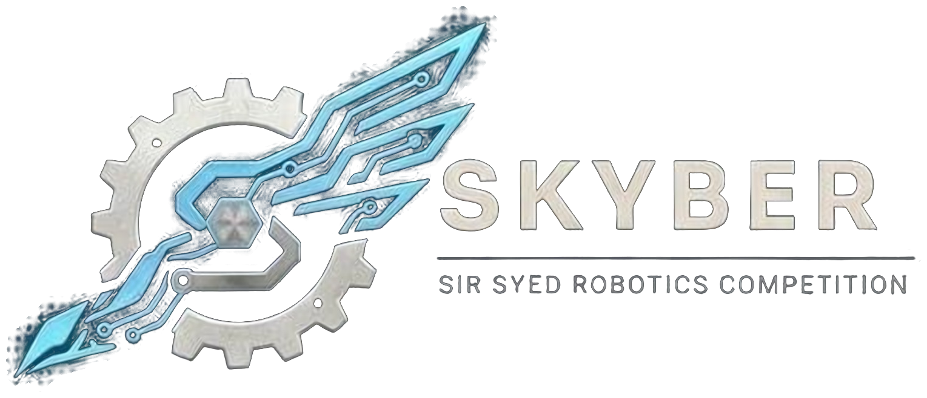 | SIR SYED ROBOTICS COMPETITION  SKYBER 2026 | SSUET | OFFICIAL RULEBOOK | 

PROJECT EXHIBITION MODULE: OFFICIAL RULEBOOK
1. Introduction
This rulebook covers the Project Exhibition at SKYBER 2026, organized at Sir Syed University of Engineering & Technology. Teams show a working project or prototype with a supporting poster, and demonstrate it to judges and visitors. By registering, participants agree to follow every rule in it. There is one track.
2. General Rules
- Eligibility: Open to university and college students aged 18 or over. No one under 18 may attend. Proof of enrollment (confirmation text or email, or registration number) is required.
- Registration: Register before the deadline (16 November 2026) with accurate details and the entry fee as announced on the SKYBER 2026 page. Late or incomplete registrations may be rejected. Each project can be registered once.
- Application: The registration includes a one-page description (problem, solution, what will be shown), a photo or short video, the space and power needed, and a statement of who did what and what was bought or borrowed.
- Punctuality and conduct: Arrive on time, finish setup before judging, stay at your stand during judging hours, follow organizers’ instructions, respect everyone and keep your area clean.
- Safety: Operate prototypes safely. Unsafe demonstrations may be stopped.
- Academic integrity: Plagiarism, false authorship claims, fabricated results, cheating and interfering with other teams’ work are prohibited. Acknowledge sources and describe your project’s development, limitations and individual contributions accurately. Violations may lead to disqualification without a refund.
3. Team Formation
Module | Team size | Fee (PKR)
Project Exhibition | Up to 3 members | As announced on the SKYBER 2026 page

- Roster: Team members cannot be added or changed after registration closes on 16 November 2026. Students from different institutions may join one team.
- Projects: The project must be the team’s own work and the team must be able to explain every part of it. Commercial products relabeled as projects are not allowed.
- ID card: Every participant shows a printed ID card at entry. The template is sent with the registration confirmation.
4. Exhibition Format
- Format: Judges visit each team’s stand, where participants present their work and answer technical questions.
- Stand: One table per project, set up between 08:30 and 10:00. Power only from the sockets assigned. An exhibit that needs more power or space must say so in the application.
- Presence: At least one team member stays at the stand from 10:30 to 15:00. If no one is present at a judge’s visit, the judge returns once; if no one is present again, that visit is not scored.
- Electrical safety: Mains-powered exhibits use a protected extension board and pass an electrical check at set-up. No open flames, chemicals, pressure vessels or lasers above Class 2.
Poster specifications
Item | Requirement
Size | A1 (594 × 841 mm), portrait.
Content | Title, team members and institution, objective, methodology, results, conclusion and references.
Printing | Posters are printed by the team before the event. A print-ready single-page PDF is the source file.
Design | Clear layout, readable text, and properly labelled figures and diagrams.

5. Judging Criteria
Criterion | Marks
Technical knowledge and methodology | 25
Working prototype / implementation and demonstration | 25
Innovation and originality | 15
Problem statement and practical relevance | 10
Poster quality and organization | 10
Explanation and response to judges | 15
Total | 100

- Visits: Two judges visit each project between 11:00 and 14:00 for about 8 minutes (a 5-minute pitch and 3 minutes of questions) and score independently. The average is the project’s first-round score. Judges do not score projects from their own institution.
- Finalists: The top 3 projects are revisited by a three-judge panel between 14:00 and 14:30. The final score is the average of the first-round score and the panel score.
- Ties: The higher working-demonstration mark, then the higher technical-knowledge mark, then the panel’s decision.
6. Disqualification and Penalties
Violation | Action
Setup not finished by 10:30 | Project is not judged
Exceeding presentation time | Warning; the presentation may be stopped
Minor misconduct | Verbal warning
Repeated misconduct | Formal warning or penalty
Plagiarism or false claims of authorship | Disqualification, no refund
Fabricated results or deliberate cheating | Disqualification, no refund
Interfering with another team’s work | Disqualification
Unsafe demonstration | Suspended until the hazard is fixed
Abusive or threatening behavior | Removal and possible disqualification

7. Queries
- Clarifications and changes: Officials may clarify rules. Any substantive change is announced to all team leaders before it is applied, and no team receives a private exception. Rules are frozen on 1st November 2026; after that only dated safety corrections are issued.
Competition Details:
Date: 18 November 2026
Venue: Sir Syed University of Engineering & Technology (SSUET), Karachi. Room to be announced.
Event: SKYBER 2026
Contact Information:
Contact no.: 03322396805
Participants are advised to follow the official SKYBER 2026 announcements for updates regarding the competition schedule, venue, reporting times and other instructions.

