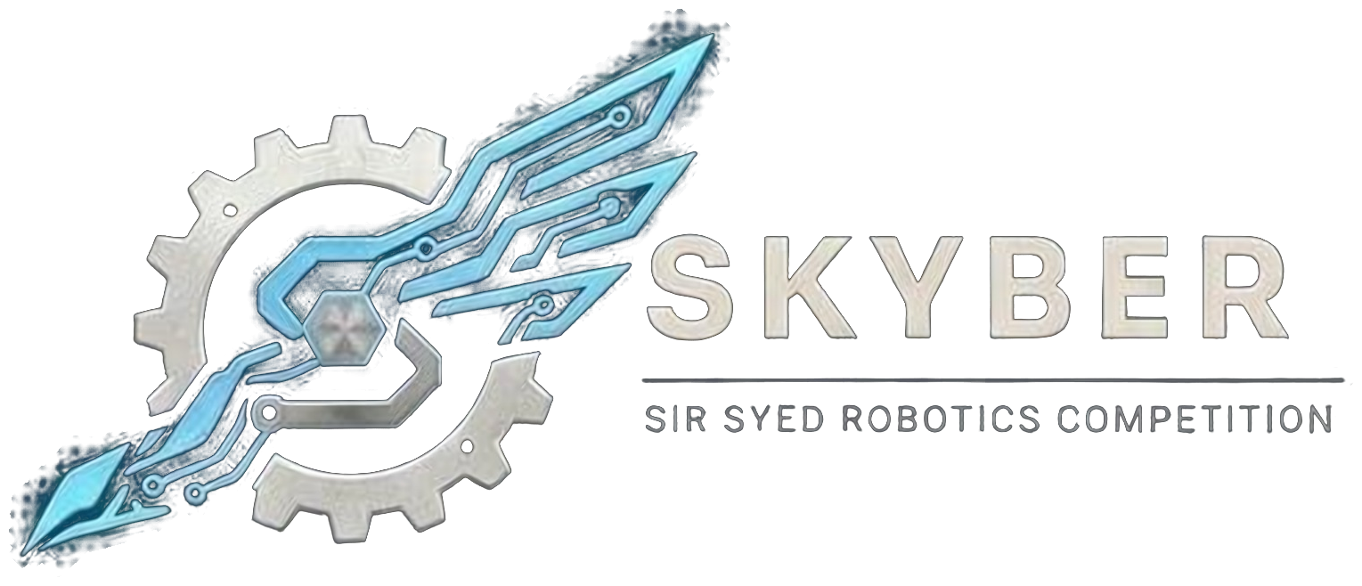 | SIR SYED ROBOTICS COMPETITION  SKYBER 2026 | SSUET | OFFICIAL RULEBOOK | 

LINE FOLLOWING ROBOT (LFR) MODULE: OFFICIAL RULEBOOK
The LFR event requires an autonomous robot to follow a black line from the start area to the finish area in the shortest possible time. The event has two stages: a Heat Round that ranks every team, and a Head-to-Head knockout for the best eight.
1. Teams:
- Eligibility: Open to university and college students aged 18 or over. No one under 18 may attend. Proof of enrollment (confirmation text or email, or registration number) is required.
- Team size: Up to 3 members. One robot per team.
- Entry fee: Rs 2,000 per team.
- Roster: Team members cannot be added or changed after registration closes on 16 November 2026. Students from different institutions may join one team.
- Multiple events: A person may belong to at most two teams, in different events, and only if the schedules do not clash.
- First-time teams: A team that has never entered a robotics competition may declare itself “first-time” at registration to be considered for the Best First-Time Team award.
- ID card: Every participant shows a printed ID card at entry. The template is sent with the registration confirmation.
2. Robot Specifications:
Parameter | Specification
Dimensions (L × W × H) | 20 × 20 × 15 cm maximum, all mounted parts included.
Weight | 2.0 kg maximum, including the battery.
Voltage | 12.6 V DC maximum when fully charged (a 3S LiPo or Li-ion pack is accepted).
Line sensors | Maximum eight (8) IR line-sensing elements, counted individually.
Other sensors | Encoders and an IMU are allowed. Cameras are prohibited.
Control | Fully autonomous. No remote control, Bluetooth, Wi-Fi or manual control during a run. Wireless modules must be removed or disconnected at the start line.
Processor and software | Any microcontroller or embedded board. Any control algorithm (PID, adaptive, learned) is allowed if it runs on the robot.
Power and switch | Onboard battery only (no combustion source). A physical ON/OFF switch is mandatory.
Single unit | The robot must remain one physical unit and may not deploy a second robot.

3. Arena and Track:
- Arena: A mirrored two-lane arena of about 2.7 m × 2.7 m. The two lanes are identical mirror images, so two robots can run at the same time from opposite start areas.
- Line: A black line 38.1 mm (1.5 inches) wide on a matte white surface. Start and finish areas are marked. Checkpoints are marked beside the line, not on it.
- Track elements: Straight lines, curves, sharp turns, 90-degree turns, intersections, narrow sections and dashed gaps. The element catalogue and a sample layout are published on 31 October 2026.
- Practice strip: A practice strip with the same line and surface is available for calibration. The competition track is not shown beforehand.
- Track reveal: The Heat Round track is revealed at the start of the Heat Round. The Head-to-Head layout is different, and the arena is re-taped between rounds.
4. Inspection and Run Procedure:
- Inspection: Officials check dimensions, weight, voltage, sensor count, switch and wireless hardware at check-in. Changing the robot after inspection without the head referee’s approval means disqualification.
- Calibration: 10 minutes on the practice strip before the Heat Round, and 2 minutes at the start line before each run.
- Start: The robot is placed in its start area and no part may cross the start line before the signal. The run starts on the referee’s signal. After the operator presses start, nobody may touch the robot.
- End of a run: Timing stops when the front of the robot crosses the finish line, at the 3-minute limit, or when the judges stop the run.
- Timing: Two stopwatches per lane, with a phone video as backup.
- No-show: A team not ready within 2 minutes of being called forfeits the attempt.
5. Tournament Format and Scoring:
5.1 Heat Round
- Attempts: Three attempts per team for up to 20 teams, two attempts for 21–30 teams, and one attempt plus one retry for non-finishers above 30 teams. Each attempt lasts at most 3 minutes.
- Running: Teams are paired and both lanes run at the same time.
- Ranking: Teams are ranked by their best completed time. Teams that do not finish rank below all finishers, by the furthest checkpoint reached and then by the time at that checkpoint. Equal results are settled by a rerun.
- Qualification: The top 8 teams qualify for the Head-to-Head Round and are seeded by heat time.
5.2 Faults
- A fault occurs when the robot leaves the line, becomes stuck, flips or is otherwise unable to continue.
- On a fault, a team member called in by the referee picks up the robot and places it at the last checkpoint it crossed (at the start area if no checkpoint has been crossed).
- The clock keeps running. There is no limit on the number of faults inside the time limit.
- The robot must resume autonomous operation immediately. Nobody may push, steer or assist it.
- The judges decide which checkpoint was last crossed.
5.3 Head-to-Head Round
- Bracket: Seeds 1–8 in a single-elimination bracket (1 v 8, 4 v 5, 2 v 7, 3 v 6). The higher seed chooses its lane.
- Matches: Two robots start together from opposite ends of the mirrored track. Quarter-finals and semi-finals are one run. The final and the third-place match are best of 3 with lane swaps.
- Winner: The robot that finishes if only one does; otherwise the faster time; otherwise the furthest checkpoint; otherwise a rerun with a lane swap.
- Between rounds: Teams have 10 minutes for repairs.
5.4 Awards
- First, second and third place. The winner receives a cash prize and a plaque; certificates are given to all participants, with a separate certificate for 2nd and 3rd place.
- A Best First-Time Team award is decided from the Heat Round results among teams that declared themselves first-time.
6. Rules, Violations and Disqualification:
- Run invalidated: Touching or guiding the robot during a run, deliberately bypassing a section of the track, or using remote control or any wireless link.
- Disqualification: Deliberate damage to the arena; deliberate interference with another team; use of a second robot; unsafe operation; changing the robot after inspection without approval; repeated or serious rule violations; any act against fair play.
- Reruns: A run is repeated only for an arena malfunction, a false start caused by an official, outside interference or a timing failure. A poor run or a robot failure is not a reason for a rerun.
- Conduct: All members are expected to be responsible, follow these rules and respect organizers, judges, volunteers and other teams. Fighting, abusive language, harassment or unruly behavior means immediate disqualification and removal from the premises.
7. Safety:
- Batteries: LiPo packs stay in fire-resistant bags (supplied by the team) whenever they are outside the robot. There is no charging at the venue, so teams arrive with charged packs and spares. Swollen, damaged or unlabelled packs are rejected at inspection. Batteries and wiring must be secured and insulated against short circuits, with no exposed wires.
- Hazards: No sharp edges or dangerous moving parts. No flames, explosives, chemicals, liquids or pressurized systems. Lasers and bright lights must be eye-safe (Class 2 or below).
- Authority: Referees and inspectors may halt, disable or disqualify any robot judged a fire or physical hazard. Marshals may require eye protection near arenas.
- Responsibility: Teams are fully responsible for the structural integrity and electrical safety of their robot. The organizers and the university are not liable for damage to robots.
8. Queries:
- Clarifications and changes: Officials may clarify rules. Any substantive change is announced to all team leaders before it is applied, and no team receives a private exception. Rules are frozen on 1st November 2026; after that only dated safety corrections are issued.
Competition Details:
Date: 18 November 2026
Venue: Sir Syed University of Engineering & Technology (SSUET), Karachi. Room to be announced.
Event: SKYBER 2026
Contact Information:
Contact no.: 03322396805
Participants are advised to follow the official SKYBER 2026 announcements for updates regarding the competition schedule, venue, reporting times and other instructions.

