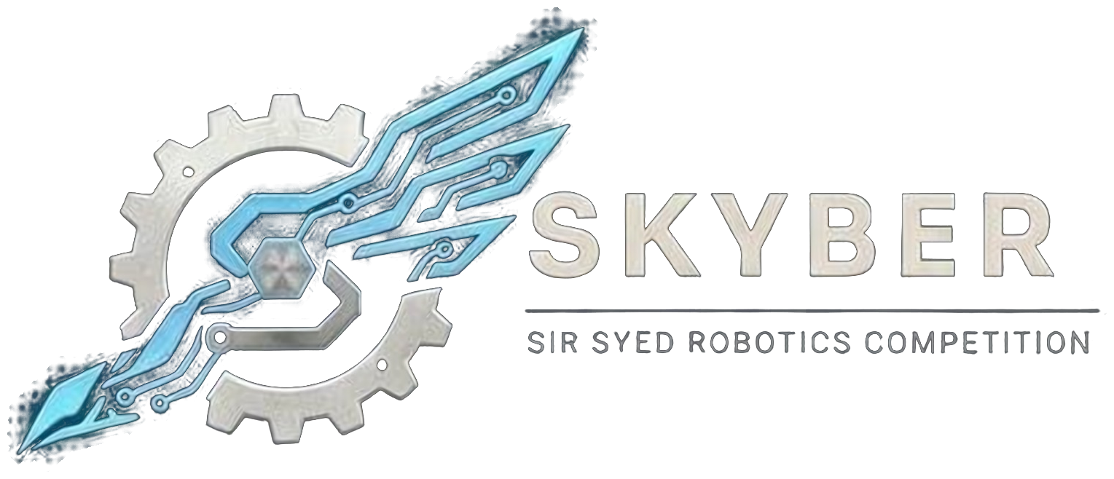 | SIR SYED ROBOTICS COMPETITION  SKYBER 2026 | SSUET | OFFICIAL RULEBOOK | 

CIRCUIT DESIGN AND SIMULATION MODULE: OFFICIAL RULEBOOK
This event combines circuit simulation and hands-on circuit design. Every team takes part in a simulation stage on a lab computer. The best teams then build a digital-logic circuit on breadboards in a hardware stage.
1. General Rules:
- Eligibility: Open to university and college students aged 18 or over. No one under 18 may attend. Proof of enrollment (confirmation text or email, or registration number) is required.
- Team size: A minimum of 2 and a maximum of 3 members. Each team uses one lab computer.
- Entry fee: Rs 1,000 per team.
- Registration: Team members cannot be added or changed after registration closes on 16 November 2026.
- Check-in: Teams check in 10 minutes before the start. Late teams are not given extra time.
- Materials: Scientific calculators and your own pens or pencils are allowed. Rough sheets are provided. The lab computers, simulation software, breadboards, ICs, wires and power supplies are provided by the university.
- Conduct: All members are expected to be responsible, follow these rules and respect organizers, judges, volunteers and other teams. Fighting, abusive language, harassment or unruly behavior means immediate disqualification and removal from the premises.
- ID card: Every participant shows a printed ID card at entry. The template is sent with the registration confirmation.
2. Game Rules:
Stage 1: Simulation (all teams)
There are three rounds, each with a 5-minute break after it. The rounds get harder as the competition goes on. In every round the circuit may be analog or digital.
Round | Time | Points | Task
Round 1: Fix the Fault | 10 min | 20 | A ready-made circuit with faults. Find and fix them, then save a screenshot of the working circuit with the measured readings visible.
Round 2: Quick Build | 15 min | 30 | Build a circuit that reaches the target output while following the given conditions. Save a screenshot showing the circuit and the measured result.
Round 3: Design | 25 min | 50 | A scenario is given. Build a circuit that produces it. Save a screenshot and the circuit file.

- Raise your hand when you finish a round. A volunteer notes the finish time.
- Save your screenshots and circuit files in a folder named with your team number.
- Begin and stop on the organizers’ signal. Work done after time is up is not counted. Keep any circuit you build open on screen so it can be verified.
Stage 2: Hardware (top 6 teams)
- The six teams with the highest Stage 1 totals take part. The task, a Digital Logic Design problem, is announced at the start of the stage.
- Teams have 45 minutes to build and demonstrate the circuit on breadboards, using the ICs, wires and power supplies provided by the organizers.
- The circuit must meet the given specification and demonstrate the required logical function.
Stage 2 criterion | Points
Functional correctness | 20
Correct circuit connections | 10
Implementation accuracy | 5
Completion within time | 5
Testing and demonstration | 5
Total | 45

3. Resources and Conduct:
Permitted | Not permitted
The lab computer provided, with the simulation software  Your own pen and calculator  A rough sheet from the organizers  The components provided (Stage 2) | The internet  AI tools of any kind  Mobile phones  Help from outside, or sharing answers with other teams  Pre-built circuit files

Every team is assessed against the same checklist and answer key. Answers are accepted within set ranges, so small differences between software tools do not affect results. If a computer or the software fails during a round, the team moves to a spare computer and the lost time is credited.
4. Scoring and Ranking:
- Stage 1 total: 100 points: Round 1 is worth 20, Round 2 is worth 30 and Round 3 is worth 50.
- Final score for the top 6: 40% of the Stage 1 total plus 60% of the Stage 2 score converted to 100 (Stage 2 score ÷ 45 × 100).
- Teams ranked 7th and below: Ranked by their Stage 1 total.
- Ties: The higher Stage 2 score, then the earlier Stage 1 finish time.
- Awards: First, second and third place. The winner receives a cash prize and a plaque; certificates for all participants, with a separate certificate for 2nd and 3rd place.
5. Penalties:
Offence | Consequence
Use of AI tools or outside assistance | Disqualification
Use of a phone, or disrespectful or disruptive behavior toward organizers, judges or other participants | A warning, then disqualification for a repeat offence
Use of pre-built circuit files | Zero marks for that round, or disqualification if deliberate

6. Queries:
- Clarifications and changes: Officials may clarify rules. Any substantive change is announced to all team leaders before it is applied, and no team receives a private exception. Rules are frozen on 1st November 2026; after that only dated safety corrections are issued.

Competition Details:
Date: 18 November 2026
Venue: Sir Syed University of Engineering & Technology (SSUET), Karachi. Room to be announced.
Event: SKYBER 2026
Contact Information:
Contact no.: 03322396805
Participants are advised to follow the official SKYBER 2026 announcements for updates regarding the competition schedule, venue, reporting times and other instructions.

