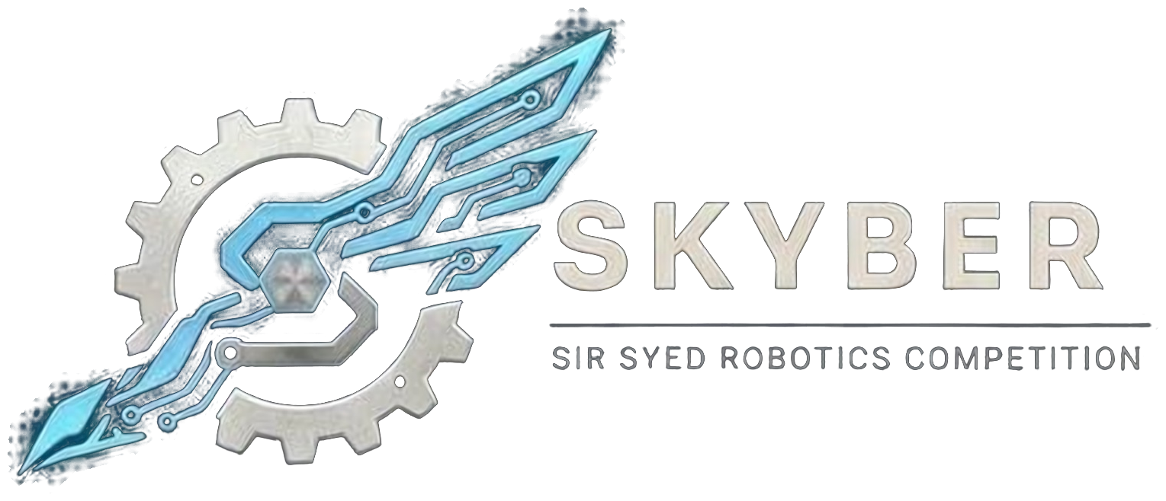 | SIR SYED ROBOTICS COMPETITION  SKYBER 2026 | SSUET | OFFICIAL RULEBOOK | 

BUILD-A-THON (HACKATHON) MODULE: OFFICIAL RULEBOOK
The Build-a-thon challenges teams to build a working solution on site in 4.5 hours, then present and demonstrate it to a jury. Teams choose one of three tracks at registration; the specific challenge within the track is released at the start.
1. Overview and Event Format:
Time | Activity
08:30–09:30 | Check-in at the registration desk.
09:30 | Briefing and release of the challenge for each track.
09:35–14:00 | Build (4.5 hours). The lunch break is 12:15–13:15 at the stalls outside; the clock does not stop.
14:00 | Freeze and submission.
14:05–15:30 | Pitches and demos: 12 teams, 7 minutes each (5-minute pitch and demo, 2 minutes of questions). One team at a time.
15:30–16:15 | Judges deliberate.
16:15–17:00 | Results at the closing ceremony.

2. Track:
- Space, flight and communications: A tool related to satellites, communication links, flight or the SKYBER glider theme (for example telemetry, tracking or simulation).
- Problem statements: Written by faculty, solvable in the time available, with a measurable demo criterion, and released to all teams at the same moment.
3. Teams:
- Eligibility: Open to university and college students aged 18 or over. No one under 18 may attend. Proof of enrollment (confirmation text or email, or registration number) is required.
- Team size: Up to 3 members. One team per person.
- Entry fee: Rs 2,500 per team.
- Roster: Team members cannot be added or changed after registration closes on 16 November 2026. Students from different institutions may join one team.
- Track choice: Teams choose their track and submit a half-page idea summary with their registration by 9 November 2026.
- Capacity: 12 teams. If more than 12 register, a faculty panel shortlists 12 on 14 November 2026 from the idea summaries.
- ID card: Every participant shows a printed ID card at entry. The template is sent with the registration confirmation.
4. Rules During the Build:
- Start: Work starts at the signal. The repository or project folder must start empty, and every commit must be after the start time.
- Allowed: Open-source libraries, datasheets and the team’s own general tools. Teams bring their own laptops and components.
- Internet: Internet access is best-effort. The challenge must not depend on it.
- AI tools: Allowed with disclosure. The team’s summary must state which tools were used and for what. Presenting generated work as entirely the team’s own without disclosure is plagiarism.
- Outside help: No help from anyone outside the registered team. Floor marshals may check commit history and the work in progress.
- Hardware and safety: No flames, chemicals or pressure systems. Soldering and hot tools are used only where a marshal permits. Mains-powered demos use a protected extension board and pass an organizer’s check.
5. Deliverables:
- A working demo (software, hardware or both).
- A 5-minute pitch followed by 2 minutes of questions.
- A link or folder with the work, and a one-page summary: the problem, the approach, what was reused, which AI tools were used, and who did what.
6. Judging:
Criterion | Marks
Working demo | 30
Technical depth and feasibility | 25
Innovation and originality | 15
Impact and problem fit | 15
Pitch and Q&A | 15
Total | 100

- Three department judges score independently on published scoring sheets. The average is the team’s score. A judge does not score a team from their own institution.
- Tie-break: the higher working-demo mark, then the higher technical mark, then a vote of the judges.
- Awards: First, second and third place. The winner receives a cash prize and a plaque; certificates for all participants, with a separate certificate for 2nd and 3rd place.
7. Disqualification and Safety:
- Plagiarism, copying commercial designs without attribution, fabricated results or submitting unoriginal work.
- Misconduct, unsporting behavior, or non-compliance with safety and organizer directives.
- Roster substitution after registration closes.
- Conduct: All members are expected to be responsible, follow these rules and respect organizers, judges, volunteers and other teams. Fighting, abusive language, harassment or unruly behavior means immediate disqualification and removal from the premises.
8. Queries:
- Clarifications and changes: Officials may clarify rules. Any substantive change is announced to all team leaders before it is applied, and no team receives a private exception. Rules are frozen on 1st November 2026; after that only dated safety corrections are issued.
Competition Details:
Date: 18 November 2026
Venue: Sir Syed University of Engineering & Technology (SSUET), Karachi. Room to be announced.
Event: SKYBER 2026
Contact no.: 03322396805
Event Updates:
Participants are advised to follow the official SKYBER 2026 announcements for updates regarding the competition schedule, venue, reporting times and other instructions.

